Dear Parent

We are sending you a link to a project called Telling it like it is: Families living on a low income with deaf children.

Here is the project website:

http://www.ssc.education.ed.ac.uk/research/tellingit/

This project is looking for families who are living on low incomes to join in an interview or a discussion group. As a local authority service we are circulating this to all parents and if you are interested, you can make contact with Theresa Monaghan from the project by SMS or phone on the number on the website: 07731 396180.

This project led by the University of Edinburgh is funded by the National Deaf Children’s Society. The results will be on the project website later in the year.

Our local authority has agreed to forward information to parents, but it is up to you whether you want to join in. If you do join in, the school service for deaf children will not know about this. People who join in won’t be named in the project report and their area or Local Authority will not be given.

Best wishes

Head of service name
Local Authority name

Telling it like it is:
families living on a low income with deaf children
Are you a parent of a deaf child aged 12 or below? Are you living on a low income? Would you be interested in talking to us in your own home, or at a nearby community building, or in a discussion group?
During March/April 2018 we will be exploring the views of families raising a deaf child or children while living on a low income. The project title Telling It Like It Is shows that we expect straight talking from families as they discuss their experiences.
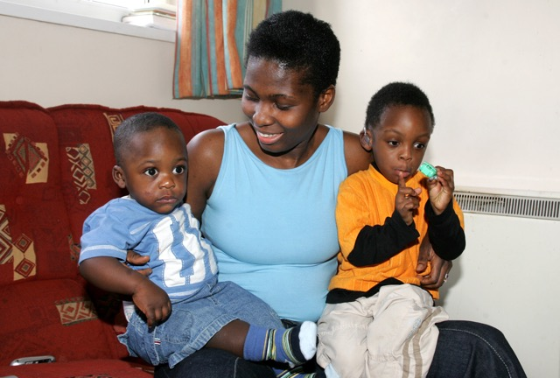
For more information about this project, please contact
- Rachel O'Neill: rachel.oneill@ed.ac.uk for general enquiries about the project. Tel 0131 651 6429.
- Theresa Monaghan: v1tmonag@exseed.ed.ac.uk if you are interested in being involved in the project, or if you know a family who may be interested.
Tel. 07731 396180.
http://www.ssc.education.ed.ac.uk/research/tellingit/

