Midlands BATOD Twilight Meeting
Tuesday 3rd July 2018
5 – 6.30 pm
Finham Park 2 School, Torrington Avenue, Coventry, CV4 9WT
'Are you teaching resilience skills this term?'
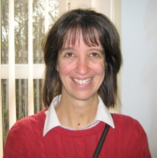
Whether you are or not, come and hear Catherine Walker talk about this interesting subject. Catherine, a teacher of the deaf in Wales, is currently writing her PhD on this topic. She will also introduce us to ideas and resources for supporting PSE development.
An opportunity to meet and network with local colleagues over light refreshments.
Please come and support this event and bring your colleagues too!

BATOD members: free Non-BATOD members: £5
Kindly hosted by the Coventry Sensory Team
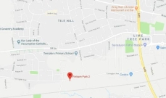
Please enter via the main school reception

Facebook page: Midlands BATOD

