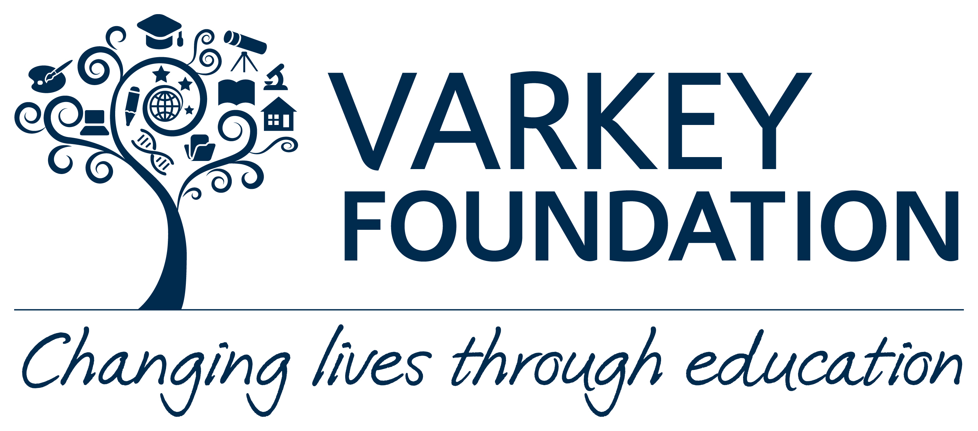

FOR IMMEDIATE RELEASE

WORLD’S MOST CELEBRATED TEACHER URGES BRITISH TEACHERS TO APPLY FOR GLOBAL TEACHER PRIZE 2019 BEFORE NOMINATIONS CLOSE

London teacher Andria Zafirakou makes the call as the 23rd September closing date for Global Teacher Prize 2019 applications approaches

Andria Zafirakou, who was awarded US$1M when declared the winner of the Varkey Foundation Global Teacher Prize 2018 in March, today urges British teachers to follow in her footsteps and apply for the 2019 award before it is too late. She also urged parents and pupils to put forward their most inspirational teacher for the prize on the day that nominations and applications opened.

The Art and Textiles teacher from Alperton Community School, Brent, London, said:

“I encourage any inspirational British teacher to apply for the prize, to come forward in order to help showcase and celebrate the great work they’re doing in preparing young people for a future which is hugely unpredictable.

I also encourage everyone in the UK, from politicians to parents, to support teachers in every way they can. After all, If the next generation are to meet the colossal challenges they face in a world made all the more uncertain by the rapid pace of technological change, they will need the very best education and that starts with teachers.

Winning the Global Teacher Prize 2018 has been a life-changing experience for me. But far more importantly, it has helped me shine a spotlight on the vital importance of increasing respect for teachers and unearthed the awe-inspiring stories of thousands of my peers across the world. And it has allowed me to help campaign to change the lives of pupils in my country by championing the transformative power of the arts in our schools.”

Many UK teachers have been shortlisted for the Global Teacher Prize since its launch in 2015. This year the shortlist also featured Rebecca Cramer, a science teacher from Reach Academy Feltham, Middlesex, Eartha Pond, a physical education and sports teacher from The Crest Academy, Neasden, London and Tuesday Humby, Principal at Ormiston Chadwick Academy, Widnes, Cheshire. Raymond Chambers, a computer science teacher from Brooke Weston Academy in Corby, Northamptonshire, was a top 10 finalist in 2017. That same year Adnan Mahmood, a business and enterprise tutor from Barking and Dagenham College, Essex, Nathan Atkinson, headteacher at Richmond Hill Primary School, Leeds; and Peter Ferris, a drama teacher from Mercy College, Belfast, also made the top 50 shortlist. Colin Hegarty, a maths teacher from Preston Manor School, Wembley, North West London, was a top 10 finalist in 2016, while Janet Hayward from Cadoxton Primary School, Barry, Vale of Glamorgan, and Sean Bellamy from Sands School, Ashburton, Devon, reached the top 50. Richard Spencer, a biology teacher at Middlesbrough College in Middlesbrough, was a top 10 finalist in 2015, while Tom Bennett, a teacher from Jo Richardson Community School, Dagenham, Essex, made the top 50.

Nominations for the US$1 million award, which is now in its fifth year and the largest prize of its kind in education, can be made at www.globalteacherprize.org. All nominations must be made by the closing date of Sunday 23rd September.

If UK teachers apply, or are nominated and then apply, they could be potentially shortlisted as Top 50 candidates later in the year and their inspirational stories publicised, helping to raise the bar of respect for the profession.

Andria Zafirakou won the 2018 Global Teacher Prize in March this year at the Global Education and Skills Forum in Dubai. The glittering award ceremony was hosted by comedian and actor Trevor Noah and included a special musical performance by Oscar-winning actress and Grammy award-winning singer Jennifer Hudson. Four time Formula One world champion Lewis Hamilton raced to the ceremony escorted by three Dubai Police supercars to deliver the Global Teacher Prize trophy to the stage and Prime Minister Theresa May delivered a special video message to the ceremony thanking Andria for her work.

The applicants for the Global Teacher Prize 2019 will be shortlisted down to a Top 50 (expected to be announced in December 2018) and then a final Top 10 (expected to be announced in February 2019). The winner will be chosen from the 10 finalists by the Global Teacher Prize Academy made up of prominent individuals.

All 10 finalists will be flown to Dubai for an award ceremony taking place at the Global Education and Skills Forum in March 2019 where the winner will be announced live.

The prize is open to currently working teachers who teach children that are in compulsory schooling, or are between the ages of five and eighteen. Teachers who teach children age 4+ in an Early Years government-recognised curriculum are also eligible, as are teachers who teach on a part-time basis, and teachers of online courses. Teachers must spend at least 10 hours per week teaching children and plan to remain in the profession for the next 5 years. It is open to teachers in every kind of school and, subject to local laws, in every country in the world.

If teachers are being nominated, the person nominating them will write a brief description online explaining why. The teacher being nominated will then be sent an email letting them know they’ve been nominated and inviting them to apply for the prize. Applicants can apply in English, Mandarin, Arabic, French, Spanish, Portuguese and Russian. To join the conversation online follow @TeacherPrize on: www.twitter.com/TeacherPrize and www.facebook.com/TeacherPrize

-ENDS-

Notes to editors:

1. The Varkey Foundation believes every child deserves a vibrant, stimulating learning environment that awakens and supports their full potential. We believe nothing is more important to achieving this than the passion and quality of teachers. We support global teaching capacity and seed excellence and innovation in the next generation of educators. We also founded the Global Teacher Prize to shine a spotlight on the incredible work teachers do all over the world. https://www.varkeyfoundation.org

2. The Top 50 shortlisted teachers will be narrowed down to the final Top 10 teachers by a Prize Committee. The winner will then be chosen from these Top 10 finalists by the Global Teacher Prize Academy. The Prize Committee and the Academy will look for evidence that applicants for the Varkey Foundation Global Teacher Prize meet the following criteria:

- Employing effective instructional practices that are replicable and scalable to influence the quality of education globally.
- Employing innovative instructional practices that address the particular challenges of the school, community or country and which have shown sufficient evidence to suggest they could be effective in addressing such challenges in a new way.
- Achieving demonstrable student learning outcomes in the classroom.
- Impact in the community beyond the classroom that provide unique and distinguished models of excellence for the teaching profession and others.
- Helping children become global citizens through providing them with a values-based education that equips them for a world where they will potentially live, work and socialise with people from many different nationalities, cultures and religions.
- Improving the teaching profession through helping to raise the bar of teaching, sharing best practice, and helping colleagues overcome any challenges they face in their school.
- Teacher recognition from governments, national teaching organisations, head-teachers, colleagues, members of the wider community or pupils.

