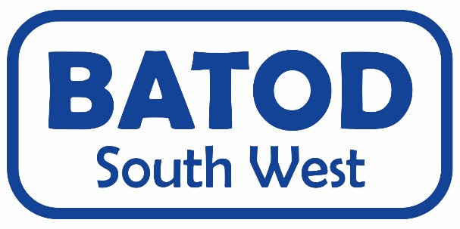
13th October 2018 AGENDA

Morning – How are we using BSL with deaf CYP?
9.30am - meet and greet, tea/coffee/biscuits
9.50 – 10am - Welcome and housekeeping
10am – 11am - BSL GCSE curriculum
11am – 12pm - BSL curriculum for Deaf children
12pm – 1pm - BSL/Deaf culture, what should be included, what else? (discussion groups?)
1pm – 1.45 - Lunch (selection of sandwiches and cakes,
tea and coffee)

(1.30 – 1.45 AGM)

Afternoon – what is new in technological support to access sounds for deaf CYP?
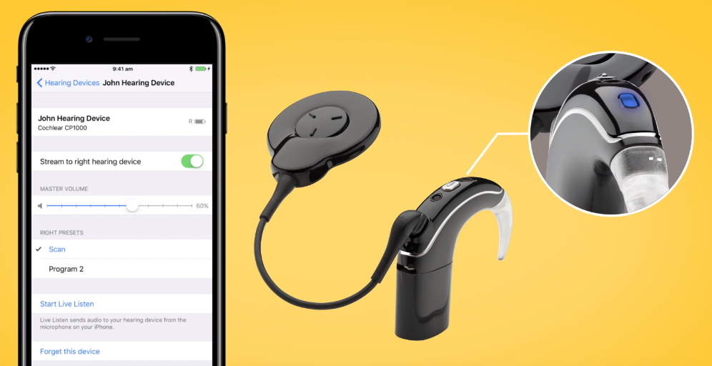
1.45 – 2.05 - Cochlear updates
2.05 – 2.25 - Phonak updates
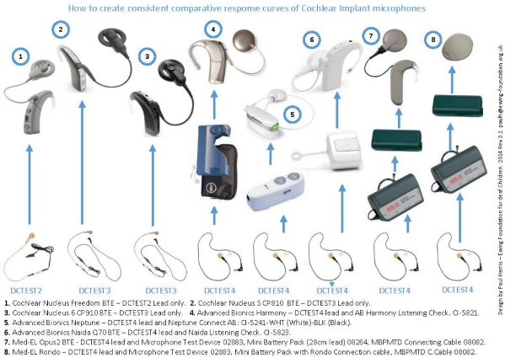
2.25 – 3.30 - N7 and testbox processes - hands on session
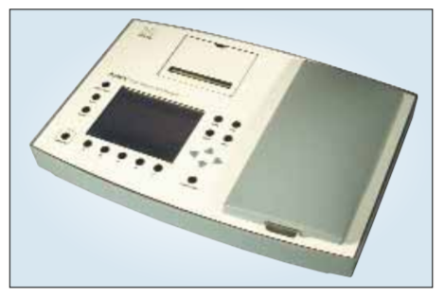

I would like to attend the BATOD South West meeting
at Exeter Royal Academy for Deaf Education, 50 Topsham Road, Exeter EX2 4NF
SATURDAY 13th October 2018
9.30am – 3.30pm at a cost of £15

Name

Email address

Job title

Local Authority/ other
Member of BATOD | Yes No
Any special dietary requirements
Any special access requirements
Interpreter | We need this information ASAP please as we will cancel if not required
Suggestions for topics for future meetings
Suggestions or offers of venues for future meetings
A charge of £15 is for the day | I enclose a cheque made payable to BATOD | I would prefer to pay cash on the day

Please fill in the above form and email to Jo Saunders ASAP
Email: jsaunders@st-margarets.torbay.sch.uk
Or post to: FAO: Karma Stocks
Exeter Royal Academy for Deaf Education
50 Topsham Road
Exeter
EX2 4NF

