


The Ear Foundation
Hearing & Communicating in a Technological Era

What does a ‘SUCCESSFUL’ teenager look like?

Clare Allen, Family Programme Lead 5-25s, The Ear Foundation

“I don’t think my hopes and dreams are any different, but I think you think about them more” (Mother of deaf teenager)

Whether its academic achievement, wellbeing or future employment we know that deaf teenagers are at risk of being ‘unsuccessful’. We will pose the question ‘What does a successful teenager look like?’. We will start to consider 4 main areas
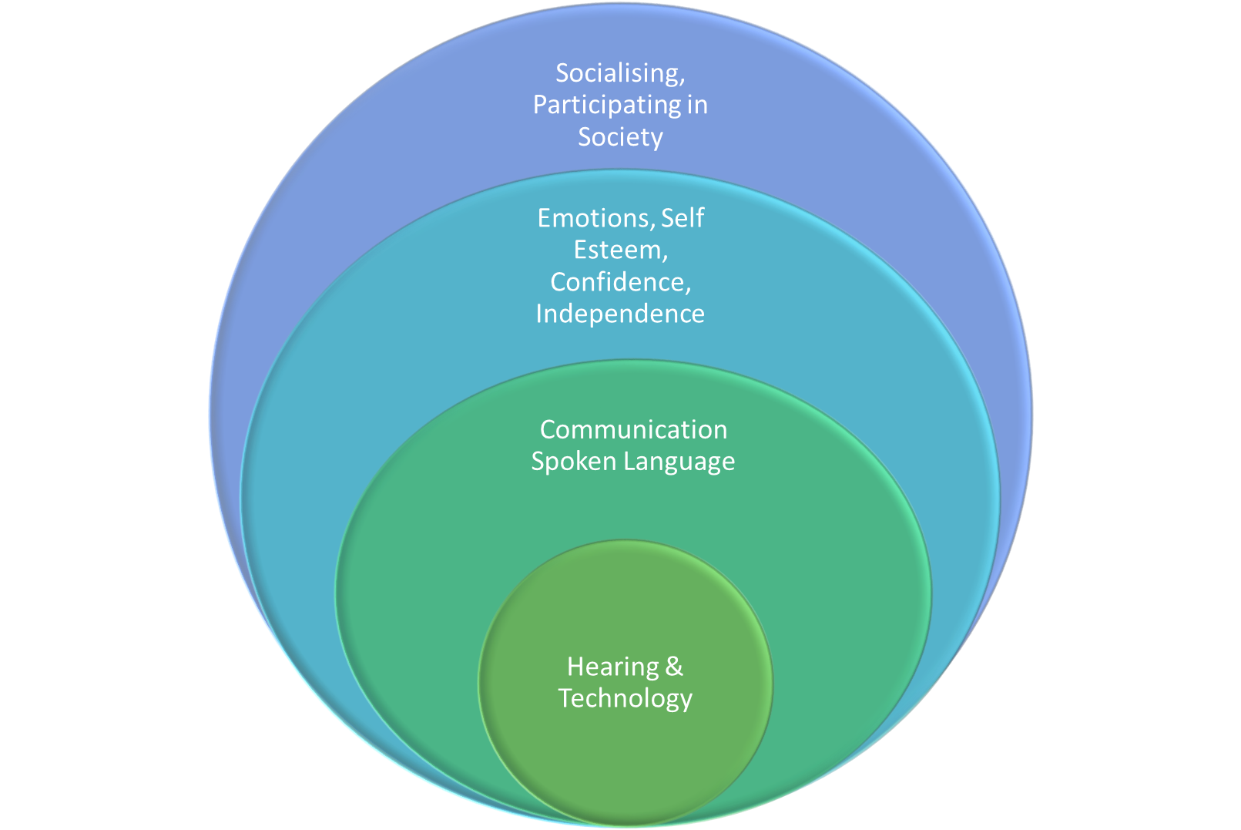
- Hearing and technology
- Communication and Spoken Language
- Self Confidence, Emotions, Independence, Self Esteem
- Socialising and participating in Society: Home, Education, Employment

This practical workshop will focus upon the 3rd level and how this permeates into all 4 areas. It will focus upon using personal stories. Oh so crucial for teenagers on Instagram and Facebook! We will look at the theory behind autobiographical memory and how essential it is. We will consider the underlying skills our deaf young people are struggling with and how we can practically put these in place during the formative years at key stage 3 and 4.

This workshop is of interest to all those working with teenagers and also those in primary schools, aiming to put things in place and promote ways of thinking which will be beneficial to them during their secondary education.

