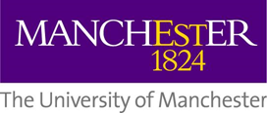
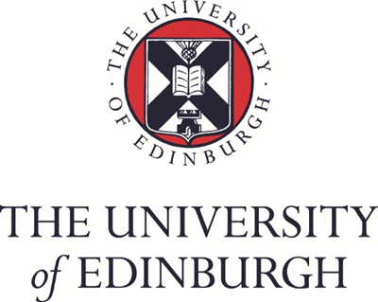
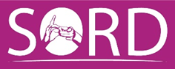
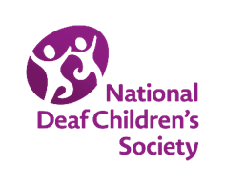

READY study logo competition – open to deaf young people between the ages of 12 and 20 years.

READY stands for Recording Emerging Adulthood in Deaf Youth
It is a research study about deaf young people between the ages of 16 and 23. It will follow over 500 deaf young people for 5 years finding out about how their lives change as they leave school, start work or do more study, develop new friendships, perhaps starts their own families, and become independent.
We want a logo for this study that we can use on all of our publicity material. It cannot be a photograph. It must be drawn. It can be one or two colours only. It must be simple to reproduce on paper and online and be very eye-catching. We would like it express the ideas:
- of life changing for young people
- of deaf young people exploring who they want to be
- and of this being a journey where the destination is not always clear
This study will involve deaf young people who communicate in lots of different ways – some will speak, some sign, some will use technology like cochlear implants, some will not. So please:
- do not choose images that seem to be about only one way to be deaf (e.g. we would not want an image that only shows voices, hearing aids/cochlear implants or signing)
- do not choose images that are about the ear – this study is focussed on people, not ears

Please send a copy of your drawing to: Ready@manchester.ac.uk
Tell us your name, contact details and age.
The closing date is 07/06/19
The winner will receive a voucher for £50 and they will be officially named on the READY study web site as the artist of our logo.
Please help us make the READY study a success!

