**Virtual School Sensory Support**

**Audiology and Covid 19 - Advice for families**

This document has been created because we are mindful that certain measures necessary during this pandemic may impact access to the curriculum for pupils who are deaf, and we wish to support them, you and schools with meeting their hearing needs.

* Please replace hearing aid batteries every Monday morning, to reduce the risk of them needing to be changed at school during the week.
* For younger children, consider buying a headband in order to reduce the chances of hearing aid(s) or speech processor(s) becoming dislodged while your child is in school.

<https://www.facebook.com/MyEarHeadbands/>

* If your child is currently unable to insert their hearing aids independently, please practise with them putting the hearing aid(s) and ear mould(s) back in place by themselves. This can be tricky, but the more independently they can manage their equipment, the better for them, and the less risk there is of them being in school and unable to hear well, if staff are unable to assist.
* Consider if you are willing to be called into school if your child’s audiological equipment needs adult attention – school staff may be unable to deal with this while social distancing.
* We have advised schools that any child who wears hearing aid(s) or speech processor(s) should sit at the front of the classroom, in the best position to be able to hear and lip read the teacher.
* If you have a child who has a radio aid system, we have established that use of these devices is viable, should schools and families be comfortable with this, as they can be cleaned within the current guidelines. If there are concerns about cleaning the fabric lanyard for the Roger Pen and Roger Touchscreen, then the lanyard can be removed (for the Roger Touchscreen by carefully using the release button on the back of the device) and the transmitter can be used in desk mode (placed flat on a surface close to the teacher, or on the pupil’s desk for group work). Attention needs to be given to cleaning all parts of devices. The Inspiro radio aid systems are more challenging to clean, as they do not have an integral microphone. The[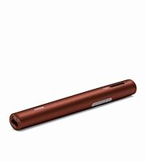](https://www.bing.com/images/search?view=detailV2&ccid=fvB2nU15&id=A1576F2FC843FF60100EF82C6DFCEF74DF9CE89E&thid=OIP.fvB2nU15WKdwq6ZwIosypgHaHa&mediaurl=http%3a%2f%2fphonakmarketing.ca%2fsite%2fwp-content%2fuploads%2fproduct-images%2froger_pen%2f052-3191-P9_Roger_Pen.jpg&exph=3000&expw=3000&q=roger+pen&simid=608014575820344685&ck=99A06DCA8B6EFBFC8186EE81FBF94A1A&selectedIndex=5&FORM=IRPRST) Inspiro should be used with the clip rather than lanyard fitting, for effective cleaning purposes.

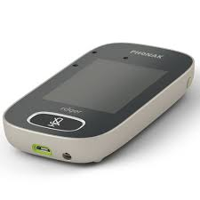 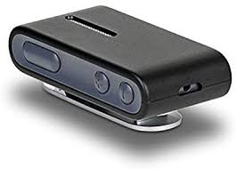 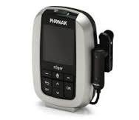

Roger Pen Roger Touchscreen ConnectClip Inspiro

* If you have a child with a radio aid system that comes home, the manufacturer’s guidance on cleaning will be shared with you. If it is to be used in school and you would rather it does not come home at present, please advise school, and ensure they have the charger.
* We have reminded schools that whether a pupil has a radio aid of not, deaf friendly communication will be even more critical than usual due to the communication obstacles presented by social distancing.

*For further support and guidance please contact your Teacher of the Deaf.*