**Virtual School Sensory Support**

**Audiology and Covid 19 - Advice for schools**

This document has been created because we are mindful that certain measures necessary during this pandemic may impact access to the curriculum for pupils who are deaf, and we wish to support them and you with mitigating this.

Please could all staff working with a child or young person who is deaf and has audiology equipment, such as hearing aids, read this.

* Please ensure that any pupil in your school who wears hearing aid(s) or speech processor(s) sits at the front of the classroom, in the best position to be able to hear you, and to lip read you and their peers. Lip reading is often an essential element of communication for children and young people who are deaf. Our understanding is that staff will not be wearing masks.
* For younger children, if their hearing aids become dislodged, consider if you are willing and able to replace them (washing your hands before and afterwards and wearing protective gloves if preferred). Due to distancing rules, this may not be possible, if so, please consider an arrangement where you can contact the parents/carers to ask if they can come to the school site to help.
* We have asked families to insert fresh batteries into hearing aids on Monday mornings, to minimise the risk of battery failure/the need to change batteries at school.
* If a pupil is left without their amplification during the day, be mindful of the safety implications as they are unlikely to hear/understand fully what is being said to them, particularly if the speaker is at a distance of more than 2 metres.
* [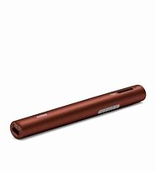](https://www.bing.com/images/search?view=detailV2&ccid=fvB2nU15&id=A1576F2FC843FF60100EF82C6DFCEF74DF9CE89E&thid=OIP.fvB2nU15WKdwq6ZwIosypgHaHa&mediaurl=http%3a%2f%2fphonakmarketing.ca%2fsite%2fwp-content%2fuploads%2fproduct-images%2froger_pen%2f052-3191-P9_Roger_Pen.jpg&exph=3000&expw=3000&q=roger+pen&simid=608014575820344685&ck=99A06DCA8B6EFBFC8186EE81FBF94A1A&selectedIndex=5&FORM=IRPRST)If you have a pupil who has a radio aid system, we have established that use of these devices could be viable, should schools and families be comfortable with this, as they can be cleaned within the current guidelines. If there are concerns about cleaning the fabric lanyard for the Roger Pen or Roger Touchscreen, then the lanyard can be removed (on the Roger Touchscreen by carefully using the release button on the back of the device) and the transmitter can be used in desk mode (placed flat on a surface close to the teacher, or on the pupil’s desk for group work). Attention needs to be given to cleaning all parts of devices. The Inspiro radio aid systems are more challenging to clean, as they do not have an integral microphone. The Inspiro should be used with the clip rather than lanyard fitting for effective cleaning purposes.

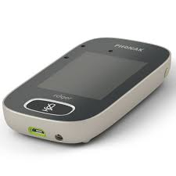 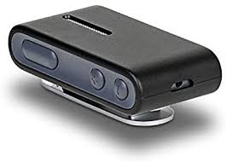 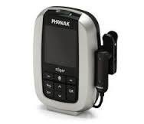

Roger Pen Roger Touchscreen ConnectClip Inspiro

* If you have a pupil with a radio aid system, the manufacturer’s guidance on cleaning will be shared with you.
* Whether a pupil has a radio aid or not, deaf friendly communication will be even more critical than usual due to the communication obstacles presented by social distancing.
* If you have a soundfield system, we would suggest that where possible only one class teacher uses/touches the microphone and speaker at present. These will also need to be cleaned.

*For further support and guidance please contact your Teacher of the Deaf.*