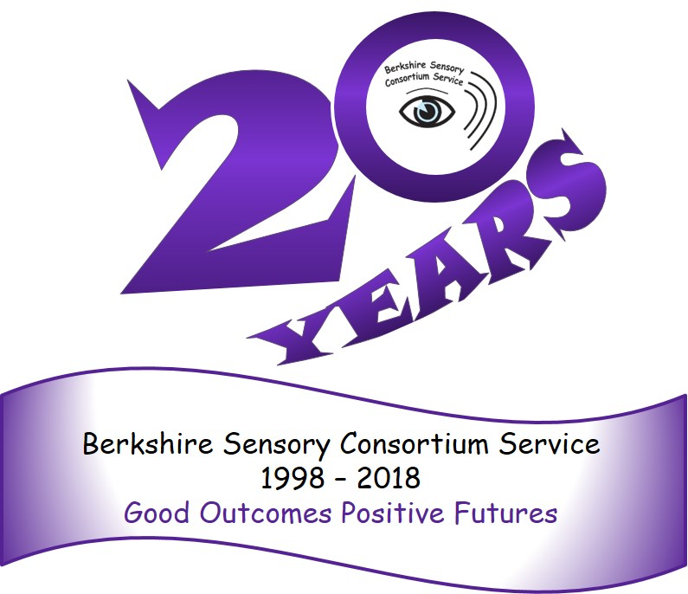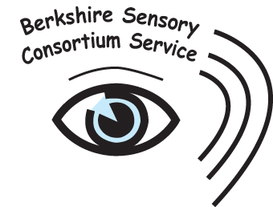

**Face coverings and Hearing Impaired Children and Young People**



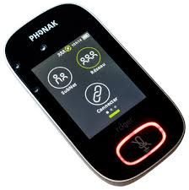

**For further information and advice please contact the HICYP’s Teacher of the Deaf**

Radio aids

It is absolutely crucial to use the HICYP’s radio aid if they have been issued with one. This helps them to access the speaker’s voice.

Radio aids are deemed as reasonable adjustments under the Equality Act 2010

Radio aids can be cleaned and disinfected after every use. See guidance here

http://btckstorage.blob.core.windows.net/site14723/Disinfecting%20Radio%20Aids%20guidelines%20for%20schools%20May%202020.pdf

It is critical to remember that the wearing of a face covering can have **serious implications** for a hearing impaired child or young person (HICYP) Challenges include

* Inability to lipread
* Voice of the speaker is muffled and clarity of the speech is reduced
* Increased chances to mishear and or/misunderstand
* Reluctance to engage in communications which are challenging, leading to withdrawal and isolation

Research has shown that the wearing of a face covering can reduce the level of speech by between 3dB and 12dB. For a child with a hearing loss this may mean that the speaker’s voice is completely inaudible to them and with the added inability to lipread this can be catastrophic

Clear panelled face masks are available and may aid lipreading, however for some HICYP the sound quality and the fogging up of the masks can cause more difficulty than a surgical mask.

**TALK TO THE HICYP TO FIND OUT WHAT WORKS BEST FOR THEM**

Current Government Guidance (8th March- Easter break) due to be reviewed before the beginning of the Summer Term

Face coverings to be used in classrooms for *secondary age* pupils and staff unless social distancing can be maintained

The guidance maintains previous exemptions for those who *speak to or provide help to someone who relies on lip reading, clear sound or facial expression to communicate*

https://assets.publishing.service.gov.uk/government/uploads/system/uploads/attachment_data/file/963541/Schools_coronavirus_operational_guidance.pdf