**Virtual School Sensory Support**

**Audiology and Covid 19 - Advice for families**

Certain measures necessary during this pandemic may impact access to the curriculum for pupils who are deaf, and we wish to support them, you and schools with meeting their hearing needs.

**Batteries:**

* Please replace hearing aid batteries every Monday morning before school, to reduce the risk of them needing to be changed at school during the week.
* Your child should have spare batteries in school. For primary school pupils these should be stored by an adult in school, due to button battery safety. Secondary school students can carry their own batteries.

**Assistance:**

* If your child is currently unable to insert their hearing aids and/or change their batteries independently, please discuss this with the school, so that you can establish whether members of staff will be permitted to reinsert the hearing aids and change batteries during these times of social distancing.

**Access:**

* We have advised schools that any child who wears hearing aid(s) or speech processor(s) should sit at the front of the classroom, in the best position to be able to hear and lip read the teacher.
* [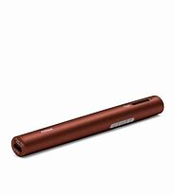](https://www.bing.com/images/search?view=detailV2&ccid=fvB2nU15&id=A1576F2FC843FF60100EF82C6DFCEF74DF9CE89E&thid=OIP.fvB2nU15WKdwq6ZwIosypgHaHa&mediaurl=http%3a%2f%2fphonakmarketing.ca%2fsite%2fwp-content%2fuploads%2fproduct-images%2froger_pen%2f052-3191-P9_Roger_Pen.jpg&exph=3000&expw=3000&q=roger+pen&simid=608014575820344685&ck=99A06DCA8B6EFBFC8186EE81FBF94A1A&selectedIndex=5&FORM=IRPRST)If you have a child who has a radio aid system, we have established that use of these devices is viable, should schools and families be comfortable with this, as they can be cleaned within the current guidelines. Attention needs to be given to cleaning all parts of devices. The Inspiro radio aid systems are more challenging to clean, as they do not have an integral microphone. The Inspiro can be used with the clip rather than lanyard fitting, for more effective cleaning purposes.

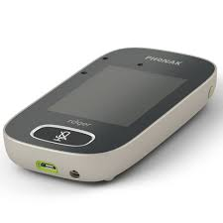 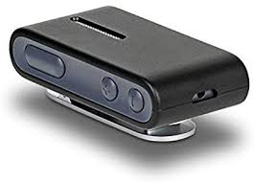 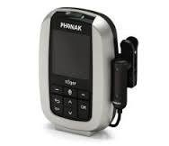

Roger Pen Roger Touchscreen ConnectClip Inspiro

* If you have a child with a radio aid system that comes home, please clean it before and after use with 70% alcohol wipes. If it is to be used in school and you would rather it does not come home at present, please advise school, and ensure they have the charger.
* We have reminded schools that whether a pupil has a radio aid or not, deaf friendly communication will be even more critical than usual due to the communication obstacles presented by social distancing. We have created a separate guidance sheet on the wearing of masks.

*For further support and guidance please contact your Teacher of the Deaf.*