**Virtual School Sensory Support**

**Audiology and Covid 19 - Advice for schools**

We are mindful that certain measures necessary during this pandemic may impact access to the curriculum for pupils who are deaf, and we wish to support them and you with mitigating this.

Please could all staff working with a child or young person who is deaf and has audiology equipment, such as hearing aids, read this.

**Access**

* Some of the necessary measures, such as doors and windows being open and some furnishings having been removed, will have a negative impact on the acoustics of classrooms. Poor acoustics will be detrimental to the speech discrimination of a child who is deaf.
* Please ensure that any pupil in your school who wears hearing aid(s) or speech processor(s) sits at the front of the classroom, in the best position to be able to hear the teacher, and to lip read the teacher and their peers. Lip reading is often an essential element of communication for children and young people who are deaf, and speech decays dramatically over distance.
* Please see our separate guidance sheet on the wearing of masks; the difficulties they present to children who are deaf and how to lessen these challenges.

**Equipment**

* We have asked families to insert fresh batteries into hearing aids on Monday mornings, to minimise the risk of battery failure/the need to change batteries at school.
* For younger children, if their hearing aids become dislodged or if they require new batteries and are unable to perform these tasks independently, consider if you are willing and able to allow staff to replace the hearing aids and/or change batteries (taking appropriate infection control measures to do so). If your risk assessment policy does not allow close contact to perform this task, we suggest discussing with parents/carers an alternative plan; such as an arrangement where parents/carers are asked if they can come to the school site to help if this is required.
* [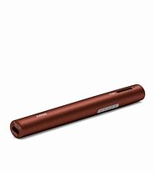](https://www.bing.com/images/search?view=detailV2&ccid=fvB2nU15&id=A1576F2FC843FF60100EF82C6DFCEF74DF9CE89E&thid=OIP.fvB2nU15WKdwq6ZwIosypgHaHa&mediaurl=http%3a%2f%2fphonakmarketing.ca%2fsite%2fwp-content%2fuploads%2fproduct-images%2froger_pen%2f052-3191-P9_Roger_Pen.jpg&exph=3000&expw=3000&q=roger+pen&simid=608014575820344685&ck=99A06DCA8B6EFBFC8186EE81FBF94A1A&selectedIndex=5&FORM=IRPRST)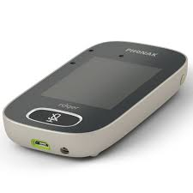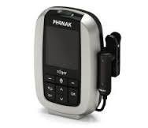If you have a pupil who has a radio aid system, we have established that use of these devices is viable, should schools and families be comfortable with this, as they can be cleaned within the current guidelines. They should be cleaned before and after each use. Attention needs to be given to cleaning all parts of devices; with 70%+ alcohol wipes. The Inspiro radio aid systems are more challenging to clean, as they do not have an integral microphone. The Inspiro could be used with the clip rather than lanyard fitting for more effective cleaning purposes.

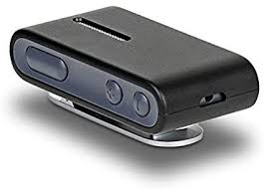

Roger Pen Roger Touchscreen ConnectClip Inspiro

* Radio aids should be linked to laptops, tablets, smartboards etc. We provide the leads to do so.
* If a radio aid goes home, we have asked families to clean all components before and after use.
* Whether a pupil has a radio aid or not, deaf friendly communication will be even more critical than usual due to the communication obstacles presented by social distancing.
* If your setting has a soundfield system, we would suggest that where possible only one class teacher uses/touches the microphone and speaker at present. These will also need to be cleaned with 70%+ alcohol wipes.

*For further support and guidance please contact your Teacher of the Deaf.*