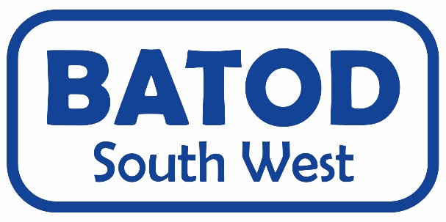
15th October 2022

Eggbuckland Vale Primary School

AGENDA

Morning – Bilingualism, QToD experiences and technology update

9.45 - 10am - meet and greet, tea/coffee/biscuits
10am - 10.10 - Welcome and housekeeping
10.10 – 10.30 - Prof. Dongbo Zhang – Meta linguistic awareness in bilingual speakers, transferability of skills and implications for literacy: shareable skills between languages; BSL/reading
10.30 – 11.10 - Hannah Anglin Jaffe – translanguaging and learning in bilingual deaf settings; BSL as tool for strategy development in learning English content
11.10 – 11.30 - Round table discussion
11.30 – 12pm - Charlotte Lynch – Experiences of a QToD
12pm – 12.30 - Dan Roberts – Updates on Assistive Listening Devices

12.30 – 1.15 - Lunch
(1pm– 1.15 AGM)

Afternoon – Acoustics, Literacy and Audiology ‘curriculum’ ideas

1.15 – 3.10 - Medel – BAHA update and connecting to ALDs/RMs - Oticon – BAHA update and connecting to ALDs/RMs
- Kathy Kenny – Cued speech
- Dan Roberts – Acoustics
3.10 – 3.30 - Discussion, Evaluations and close

I would like to attend the BATOD South West meeting
Eggbuckland Vale Primary School & Nursery - Charfield Drive, Eggbuckland,
Plymouth, Devon PL6 5PS
SATURDAY 15th October 2022
10.00am – 3.30pm at a cost of £15

Name

Email address

Job title

Local Authority/ other
Member of BATOD | Yes No
Any special dietary requirements
Any special access requirements
Interpreter required | We need this information by 23rd September 2022 at the latest as we will cancel if not required  I confirm that I can claim for this on Access to Work
Suggestions for topics for future meetings
Suggestions or offers of venues for future meetings
A charge of £15 is for the day | I confirm that I’ve paid by BAC and have used ref: ………………………………. | I would prefer to pay cash on the day

Please fill in the above form and email to Jo Saunders ASAP
Email: jsaunders@st-margarets.torbay.sch.uk
or helen.maiden@devon.gov.uk

