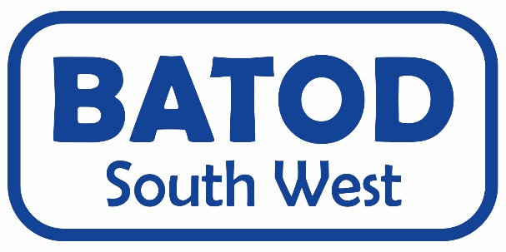
14th October 2023 AGENDA

Morning
9.45 - 10am - meet and greet, tea/coffee/biscuits
10am - 10.10 - Welcome and housekeeping
10.10 - 11am - Resources, shared by the committee and Medel
11am – 11.15 - Break
11.15 – 11.45 - Charlotte Lynch Theory of Mind
11.45 – 12.30 - Richard Evans Reading
12.30 – 1.15 - Lunch (selection of sandwiches and cakes,
tea and coffee)

1.15 – 1.30 AGM for BATOD South West
Afternoon

1.30-2.15 - Lee Fullwood Blended learning – the use and impact of pre-teaching/flipped learning and homework for deaf learners.
2.15-2.35 - Tony Murphy Phonak presentation - Q&A
2.35– 2.55 - Tanya Huckelsby/Andy Rice Access Communication Services
2.55– 3.15 - evaluation, discussion and tea
3.30 - End

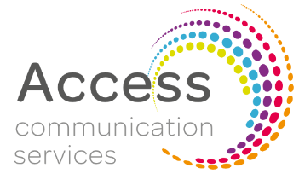
Throughout the day there will be trade displays from relevant companies
I would like to attend the BATOD South West meeting
The Deaf Academy, 1 Douglas Ave, Exmouth EX8 2AU
SATURDAY 14th October 2023
10.00am – 3.30pm at a cost of £15 (non-members £20)

Name

Email address

Job title

Local Authority/ other
Member of BATOD | Yes No
Any special dietary requirements
Any special access requirements
Interpreter | We need this information by Friday 29th September please as we will cancel if not required.
Suggestions for topics for future meetings
Suggestions or offers of venues for future meetings
A charge of £15 is for the day | I have paid by BACS (see below) | I would prefer to pay cash on the day

Please fill in the above form and email to Jo Saunders ASAP
Email: jsaunders@st-margarets.torbay.sch.uk
BACs info:
Lloyds Bank - BATOD South West Group
Sort code: 30 91 91
Account Number: 34002560

