
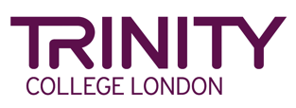
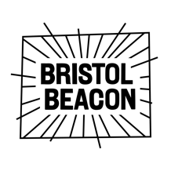

Press Release: 7th March 2024

Together For Music: The UK’s First Inclusive Music Festival for Young People, in Partnership with Music for Youth and Trinity College London

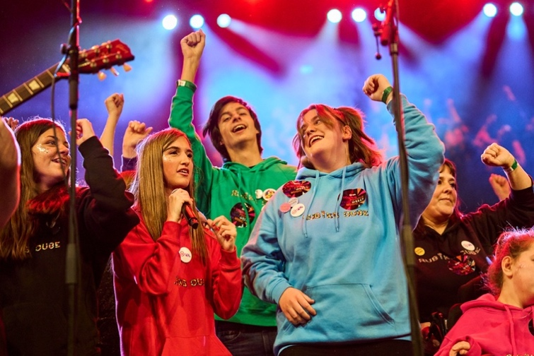
Photo credit: Alick Cotterill

Together for Music, the new fully inclusive music festival for young people in the UK, will take place at Bristol Beacon on 18th March as part of the nationwide Music for Youth festival. This pilot event will celebrate creativity and music-making of all abilities, welcoming young people from D/deaf, neurodivergent and disabled communities.
This special music event will feature performances from groups and soloists, workshops and a marketplace with Technology in Music Education (TiME) and others and talks from Trinity College London.

Phil Castang, Chief Executive of Music for Youth, said: “We are honoured to be staging this exciting music festival welcoming young people of all abilities. Inclusion is at the heart of our mission, and we believe that everyone should have the opportunity to express themselves and share their talents”.

Supported by Trinity College London’s Award and Certificates in Musical Development (ACMD) qualification, in association with the Sounds of Intent programme, Together for Music will be an exciting and accessible festival which promises to empower and inspire everyone involved. Toby Davies, Business Development Manager at Trinity says “We are immensely proud to stand alongside this inaugural event at the newly refurbished Bristol Beacon. As steadfast supporters of musical diversity and community engagement, we are honoured to be part of such a transformative celebration of the power of music to unite and inspire”

Adam Kent, Director of Creative Learning and Engagement at Bristol Beacon says:
"At Bristol Beacon we’re dedicated to creating an inclusive space where the unity and joy of live music can be shared by everyone. We can’t wait to welcome young people of all abilities from around the country to perform on the Beacon Hall stage and enjoy music making together."

This special event is part of the Music for Youth Festival 2024, a collection of regional festivals taking place in March across the UK. This is the UK’s largest festival for young musicians: https://www.mfy.org.uk/get-involved/music-for-youth-festival-2024

“This event raises awareness about equal opportunities for disabled children while also offering a platform for young musical talents like Chapman to showcase their music and uplift others. As Chapman often says: 'If I can do it, you can do it too,' encapsulating the spirit of empowerment and inclusivity” Parent of a performer.

Music For Youth’s vision is for every young person in the UK to have the opportunity to achieve their full potential through performing the music they love. The charity works with 40,000 young people every year.
For more information about Music for Youth, visit https://www.mfy.org.uk/

Sponsors and Supporters


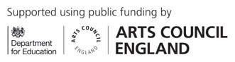




Notes to editors:
For further images, artwork, content or for interview requests, please contact Rebecca Campbell on 0771 441 8879 or email: rebecca@mfy.org.uk

