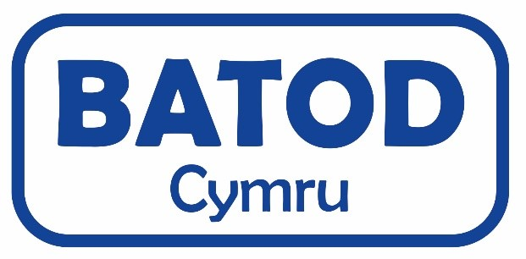

Professional Learning Community Study Day July 8th
All Nations Centre, Sachville Avenue, Heath, Cardiff. CF14 3NY
Registration from 8:30am.

A fee of £20(members - please quote membership number) or £25 (non-members) is required –
Please make Cheques payable to: BATOD Cymru or Bank Transfers payable to:
Account Name: BATOD Cymru
Sort Code: 20-18-17
Account: 63575101
Please return a completed registration form with your payment and/or request for an invoice.
It will not be possible to attend if you have not registered and paid.
Please return this form no later than Friday 14th June to:

Natalie.Budge@llanishen.cardiff.sch.uk

Title and name: ………………………………............................................................
Membership number: …………………………………………………………………………..
Role: ……………………………………………………………………………………………………………
County: …………………………………...…………………………………………………………………….............
Address:
……………………………………………………………………………………………………………………
Email:………………………………………………………………………………………………………….

(This is essential for confirmation of registration – if you do not receive confirmation by 28th June, then your registration form has not been received)

Please indicate if communication/BSL Interpreting is required: ………………………………………………………………..

Please indicate if any dietary needs are required:……………………………………………………………………

……………………………………………………………………………………

Please indicate if an invoice is required: Yes / No
Who should invoice be made out to: (Please include email address)
……………………………………………………………………………………………………………………………………………………………………………………………………………………………………………………………….

